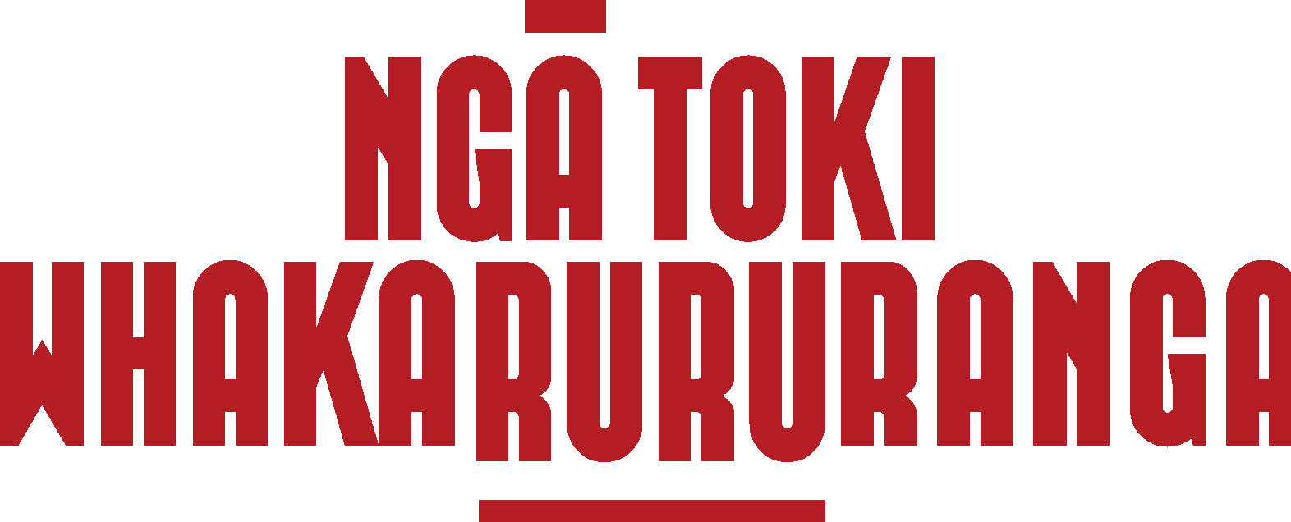 | TE WHAKATURANGA Ō MAHI / POSITION DESCRIPTION

Job title: | Te Tautīaki/ Administrator
Reports to: | Te Hiwa
Direct report(s): | N/A
Hours of work: | Part-time 25 hours per week
Remuneration: | @30 per hour $39,000 per year (excl. GST)
Employment type: | Contractor

Come and join our diverse rōpū of thinkers and doers protecting Te Tiriti o Waitangi and He Whakaputanga in the international trade arena

We’re looking for an experienced Te Tautīaki/ Administrator who can join Ngā Toki Whakarururanga to run the administration side of our operations.

About Ngā Toki Whakarururanga
We are a by-Māori, for-Māori collective whose job is to advance and protect Māori interests in the trade space.
We set the bar for Te Tiriti o Waitangi consistent trade policy, negotiations and agreements and hold ourselves accountable to te iwi Māori me ngā tamariki mokopuna hoki.
Our objectives are to:
- Advocate for and empower Māori.
- Honour Te Tiriti o Waitangi and provide Te Tiriti assessments.
- Educate our communities about the impacts of trade agreements.
- Create opportunities to connect and engage with Māori on trade-related issues.

Role Purpose
In this role you will ensure the smooth running of internal operations and logistics and being the first point of contact in our small team.
Te Tautiaki will support Te Hiwa (General Manager) to run the operations in support of the Co-convenors, Ngā Kaihautū, Ngā Pūkenga, technical experts and other secretariat staff.

Key Responsibilities
1. General Administration
- Schedule hui and administrative support for Te Hiwa.
- Schedule Kaihautū monthly hui, Kaihautū-Pūkenga hui, briefings with Co-convenors, meetings with MFAT officials, Co-convenors Leaders call with MFAT, any meetings with externals, AGM, conferences etc.
- Attend Ngā Kaihautū hui, AGM and other hui as required and take minutes.
- Manage day-to-day accounting in Xero including the uploading of receipts, invoices and remittances.
- Manage the Contact List and keep updated.
- Ensure files are kept tidy, up to date and accessible.
- Ensure the Member Register is kept up to date.
- Organise logistics for any in-person hui such as venue, catering, RSVPs, access and dietary requirements, tech, travel etc.
- Provide operational support to Te Hiwa for the running of Ngā Toki Whakarururanga.
- Ad hoc administrative tasks as required for Co-convenors, Ngā Kaihautū, Ngā Pūkenga, technical experts and other secretariat staff.

Key Outcomes  - Coordinated hui and meetings with accurate minute-taking and logistical support.  - Managed day-to-day financial administration and up-to-date record keeping.  - Operational support provided to Te Hiwa for the running of Ngā Toki Whakarurunga.  - Administrative support provided to Ngā Kaihautū, Ngā Pūkenga, and secretariat staff.  - Co-ordination of the monthly newsletter. | Key Relationships  - Te Hiwa (general manager)  - Ngā Kaihautū (governance body), Ngā Pūkenga (subject matter experts) and secretariat staff of Ngā Toki Whakarururanga  - Other Māori organisations working on trade issues  - MFAT – TEG staff  - Other government agencies as required

Person Specification
- Excellent organisational skills with strong attention to detail and the ability to manage multiple tasks and deadlines.
- Clear and confident communication skills – both written and verbal – with the ability to write newsletters, prepare minutes, and other collateral as required.
- Experience with digital tools such as Xero, Mailchimp

- A proactive and flexible approach – you’re someone who takes initiative and responds well to shifting priorities.
- A strong understanding of, and commitment to, te ao Māori and working in tikanga-informed environments.
- Experience working with Māori collectives, governance groups, or kaupapa is highly valued.
- Knowledge of te reo Māori is valued.

For more information about this role, please contact tehiwa@ngatoki.nz.
Dated: 08 July 2025

