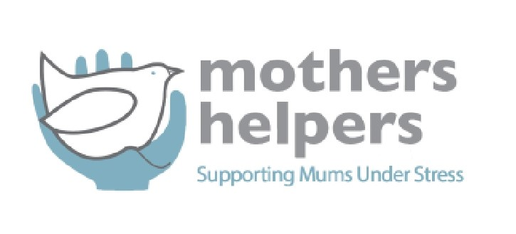

**Position: Iwi Relationships Manager**

**Location:** Aotearoa New Zealand (preferred location Auckland, Wellington or Christchurch as frequent domestic travel will be expected in this role)

**Contract:** Part-time Fixed-Term contract (20hrs/wk for 6 months)

**Salary for 6 months: $30,000-38,000 depending on experience plus travel expenses (flights and accommodation)**

We are seeking a passionate and experienced individual to join our team as an Iwi Relationships Manager for our charity based in Aotearoa New Zealand. As the Iwi Relationships Manager, you will play a key role in building and maintaining strong relationships with iwi and fostering partnerships to support our organization's mission and initiatives.

If you are dedicated to improving the wellbeing of wahine and whanau, promoting cultural understanding and partnership building and you have strong people skills and networks amongst iwi in Aotearoa we invite you to apply for this rewarding position.

**Responsibilities:**

* Develop and implement strategies to engage with iwi communities and establish meaningful relationships.
* Collaborate with iwi leaders and representatives to understand the needs and priorities of their community
* Facilitate communication and collaboration between the charity and iwi to ensure alignment of goals and values.
* Support the integration of Māori perspectives, values, and practices into the organization's programs and services.
* Work closely with the leadership team to ensure that iwi perspectives are considered in decision-making processes.
* Participate in events and initiatives that promote partnership building.

**Requirements:**

* Demonstrated experience in engaging with iwi and building successful relationships (applicants who already possess a strong network of iwi relationships around Aotearoa preferred)
* Strong understanding, appreciation and demonstration of Te Ao Māori and tikanga Māori
* Excellent communication and interpersonal skills, with the ability to work effectively with diverse stakeholders.
* Knowledge of the social sector in Aotearoa New Zealand and experience working with iwi is preferred.
* Ability to work collaboratively in a cross-cultural environment and respect cultural diversity.

To apply, please submit your CV and a cover letter outlining your relevant experience and why you are interested in the role of Iwi Relationships Manager to:

**Mothers Helpers**

**Contact: katev@mothershelpers.org.nz**

**Application Deadline: 18 April 2025**